UHS Research Order Set
IRB #: HSC201XXXX
Study Title:
Short Name:
Purpose Statement: (95 char max):

Principal Investigator (PI): name, title, contact number, e-mail, mailing address
Research Assistant (RA): name, title, contact number, e-mail
Primary contact for questions about Research Order Set: name, title, contact number, e-mail OR RA listed above OR PI listed above
Check Order Type: (check) Inpatient Or Outpatient
The following will be completed by UHS Research Office:
UHS Project #:
G Plan Code:
Laboratory Location(s):
Principal Investigator Provider ID#:

Instructions:
All studies utilizing clinical services must submit research order set for entry into the UHS electronic medical record system. The EMR system is commonly referred to as Sunrise.
Orders must be written a clear and concise manner and have the same name/nomenclature as Sunrise.

If you require information about procedures from a particular department, please contact the Research Department at 210-743-6450 or research@uhs-sa.com.

Enrollment order: All studies with or without orders require enrollment order.
Disenrollment order: All studies with or without orders require disenrollment order.

Research Enrollment Order (REQUIRED)
IRB#HSCXXXX
Study Title: XXX
Principal Investigator: NAME, EMAIL and PHONE
Patient enrolled in the above University Health System research study.

Patients screened for the above study, determined to meet all inclusion and no exclusion criteria. Participant/legal guardian approached for participation in the above study. Participant/legal guardian was informed about the study including procedures, risks and benefits. Participant/legal guardian was given the opportunity to have questions answered. All questions answered. Participant/legal guardian agreed to comply with all study procedures. Consent document was signed and the signed copy provided to subject or LAR. A signed copy was placed in chart.

For any questions please contact: Study Coordinator : NAME, EMAIL and PHONE. Add additional Contacts as needed.

Research Disenrollment Order (REQUIRED)
IRB#HSCXXXX
Study Title: XXX
Principal Investigator (PI): NAME, EMAIL and PHONE
Study Coordinator: NAME, EMAIL and PHONE

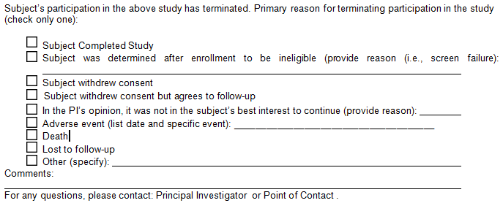

CPT codes: Required
SOFT, RIS, and Dept Codes: Optional, enter if available
Please ensure only one order entered per line, insert additional rows if required.
Some examples (EX) have been provided; make sure to delete the examples before submitting document.

Identify pathology/laboratory procedure required and submit CPT code with order
Laboratory Tests | CPT Code | Soft Lab Code | State time or phase per study requirements
EX. CBC with diff | 85025 | CBCWD | Day 1, 3, 5
EX. HCG pregnancy test (not pregnancy test) |  |  | Before randomization occurs
EX. Basic Metabolic Profile (used to be Chem 10)

Identify radiographic procedure required and submit CPT code with order
Radiology | CPT Code | RIS Code | State time or phase per study requirements
EX. Research RAD CXR 1-view | 71010 | 00838395 | Day 1, 3, 5
EX. Research RAD Liver Doppler | 76700 | 00838398 | Visit 1 to rule out portal vein Thrombosis
EX. Research RAD MRI Abdomen | 74181 | 00995606 | Beginning and end of study

Identify Cardiac/Vascular procedure required and submit CPT code with order
Cardiology/Vascular | CPT Code | Dept Code | State time or phase per study requirements
EX. Research EKG | none | none | within 28 days of treatment
EX. Research Cardiac Cath Angiogram | 93458 | 00995602 | Visit 1
EX. Research Vascular Lab ABI Lower | 93922 | 00995601 | Visit 3

Indicate the name(s) of the Investigational Drug(s). The Sunrise Orders will be created by UH research pharmacist
Medications | State time or phase per study requirements
EX. INV Avatrombopag /Placebo Tab

Please specify all the Nursing procedures and timing (nursing orders) require for the study
Nursing Interventions | State time or phase per study requirements
EX. Physical assessment to include height (cm) and weight (kg) | daily
EX. Start PIV
EX. I and O | Between investigational drug dose 1 and 2

Identify Respiratory/Pulmonary procedure required and submit CPT code with order
Respiratory | CPT Codes | State time or phase per study requirements
EX. Research RESP Sputum Induction | none
EX. Research RESP Pulmonary Function | none

Research Specific Orders | CPT Codes | State time or phase per study requirements
EX. Research Intervention | none | Used for non-standard of care treatments

